What is NoSQL
Databases can be divided in 3 types:
- RDBMS (Relational Database Management System)
- OLAP (Online Analytical Processing)
- NoSQL (recently developed database)
NoSQL Database is used to refer a non-SQL or non relational database.
It provides a mechanism for storage and retrieval of data other than tabular relations model used in relational databases. NoSQL database doesn't use tables for storing data. It is generally used to store big data and real-time web applications
No sql is document oriented database management system

Advantages of NoSQL
- It supports query language.
- It provides fast performance.
- It provides horizontal scalability.

NoSQL databases emerged in the late 2000s (Feb 2009)as the cost of storage dramatically decreased.
Examples of NoSQL databases
- Redis
- FaunaDB
- CouchDB
- MongoDB
- Cassandra

Distinctive features of MongoDB
- Easy to use
- Light Weight
- Extremely faster than RDBMS

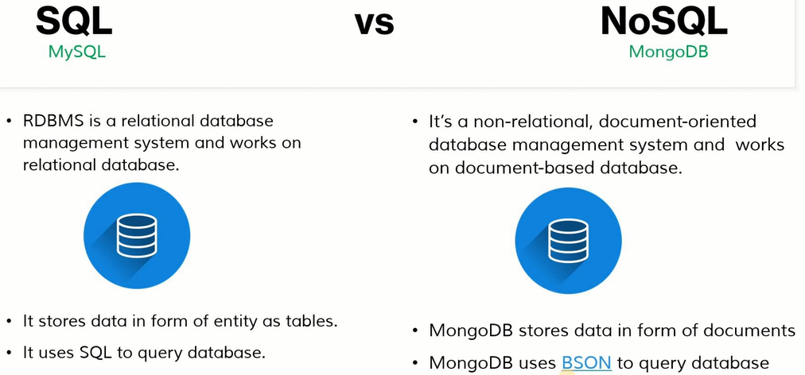

BSON stands for Binary JSON. It is a binary file format that is used to store serialized JSON documents in a binary-encoded format. It was developed in 2009 by MongoDB

SQL Table Row column =NoSql Collection,Document,Field

MongoDB Datatypes
- Following is a list of usable data types in MongoDB.
Data Types | Description
String | String is the most commonly used datatype. It is used to store data. A string must be UTF 8 valid in mongodb.
Integer | Integer is used to store the numeric value. It can be 32 bit or 64 bit depending on the server you are using.
Boolean | This datatype is used to store boolean values. It just shows YES/NO values.
Double | Double datatype stores floating point values.
Min/Max Keys | This datatype compare a value against the lowest and highest bson elements.
Arrays | This datatype is used to store a list or multiple values into a single key.
Object | Object datatype is used for embedded documents.
Null | It is used to store null values.
Symbol | It is generally used for languages that use a specific type.
Date | This datatype stores the current date or time in unix time format. It makes you possible to specify your own date time by creating object of date and pass the value of date, month, year into it.

C:\Program Files\MongoDB\Server\6.0\bin\
C:\Program Files\MongoDB\Server\6.0\log\
Uncheck mongodb compass it is for GUI

How to download MongoDB
You can download an appropriate version of MongoDB which your system supports, from the link Download MongoDB Community Server | MongoDB to install the MongoDB on Windows. You should choose correct version of MongoDB acording to your computer's Window. If you are not sure what Window version are you using, open your command prompt and execute this command:from community server of products menu
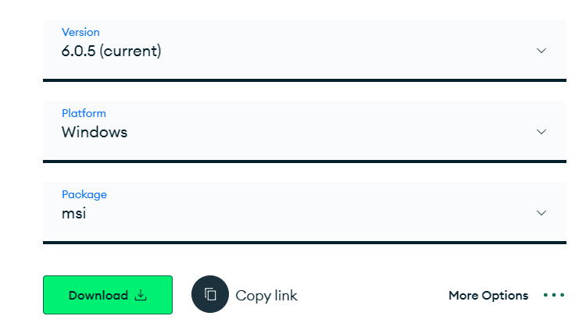
To test install
Download mogodb shell from tools
Set environment variable for server C:\Program Files\MongoDB\Server\6.0\bin
For shell C:\mongoshell\bin

Now Test that is it working
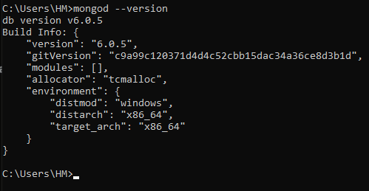
To start monodb
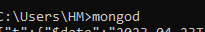
If your command prompt returning the check for error
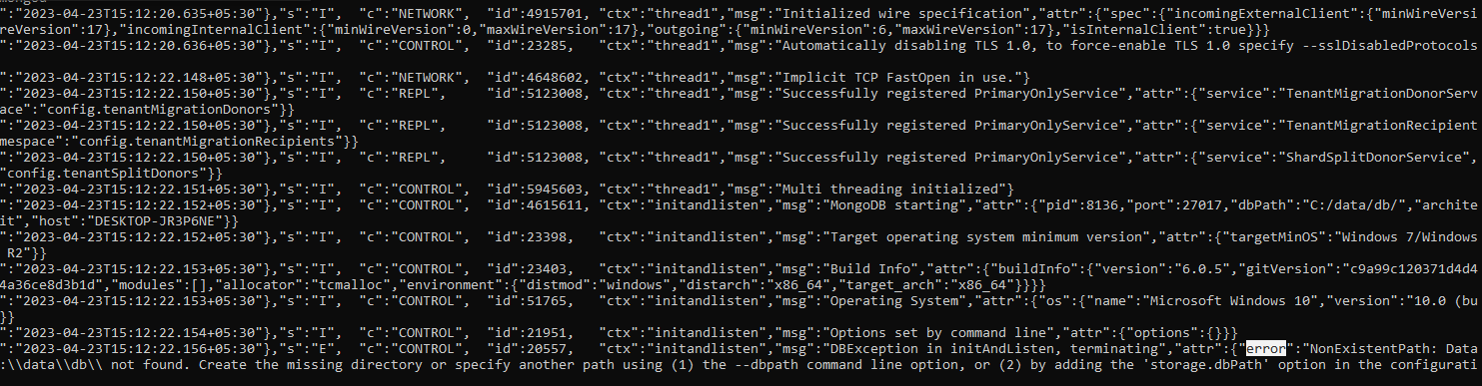
And create folder c://data/db and try again
Now command not returning back means server is started
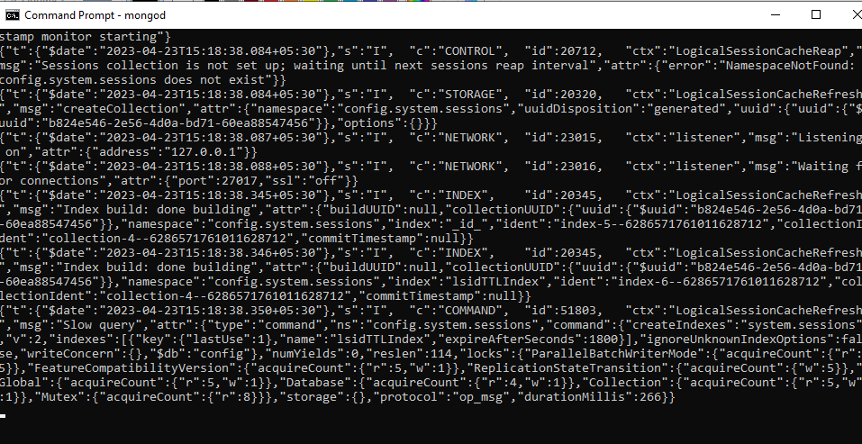
You can also start from bin folder
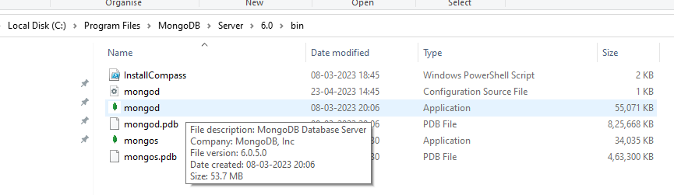
Now start mongoshell for executing query
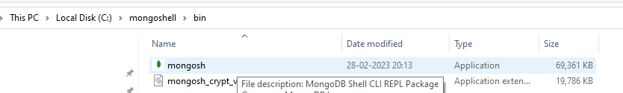
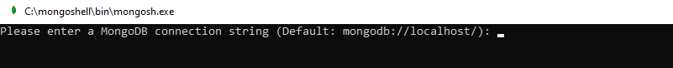
Press enter key
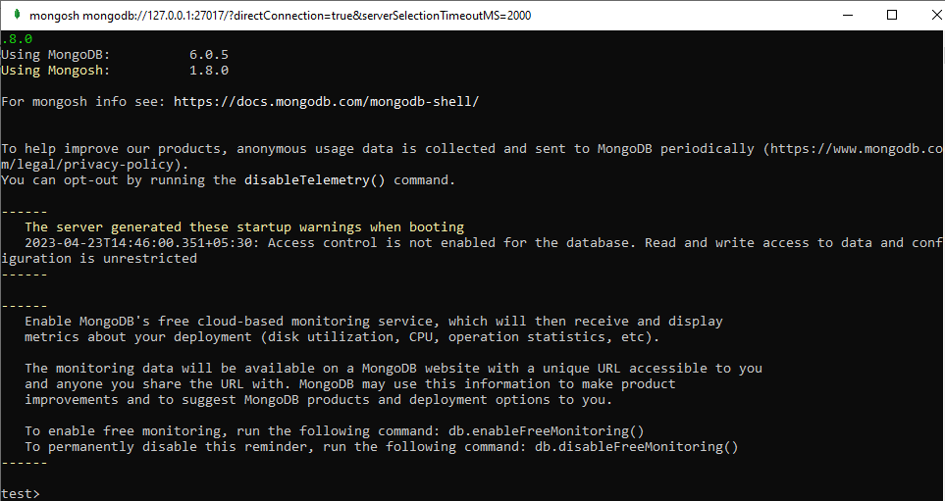
Now it has got connected to the server
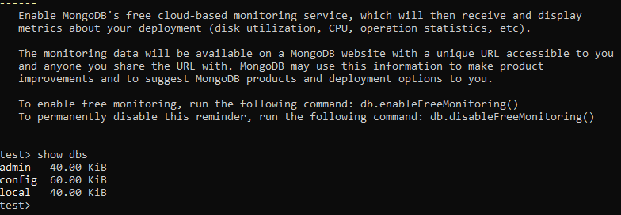
Create Database
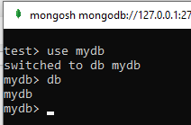

Create collection
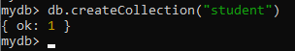
Insert Row and Field
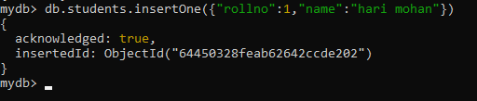
Now
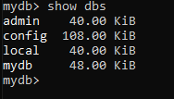
To display all the collections(table) in database
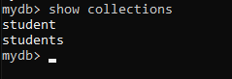
To display data in proper formate
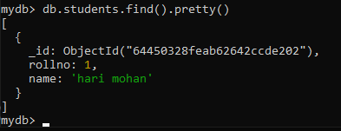
To drop(delete) collection
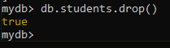
Now
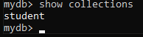
To drop database
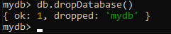
Database deleted and it will not display
